Report on Hospital Training-II

A report of training undergone at
RAM SAGAR MISHRA 100 BEDDED COMBINED HOSPITAL
Submitted in Partial Fulfillment of B. Pharm VIIth Semester
Subject- Hospital Training-II
(BP-707P)

By
Sarfraj Ansari
(2109190500051)


Session 2024-25

Dr. A. P. J. ABDUL KALAM TECHNICAL UNIVERSITY,
LUCKNOW
(Formerly Uttar Pradesh Technical University, Lucknow)

Under the Supervision of


Prof. (Dr.) Ramesh Kumar Singh Mr. Virendra Kumar Singh

BNCP, Lucknow.
BNCP, Lucknow.

to the
B. N. COLLEGE OF PHARMACY, LUCKNOW
(Affiliated to Dr. A.P.J Abdul Kalam Technical University, Lucknow)
AUGUST, 2024

CERTIFICATE

This is to certify that Mr. SARFRAJ ANSARI has been successfully completed Hospital Training-II (BP-707P) for the partial fulfillment of B. Pharm VIIth semester, as per the syllabus of Dr. A. P. J. ABDUL KALAM TECHNICAL UNIVERSITY, LUCKNOW in the academic year 2024-25.

Prof. (Dr.) Ramesh Kumar Singh Mr. Virendra Kumar Singh BNCP, Lucknow. BNCP, Lucknow.

CERTIFICATE

DECLARATION

I hereby declare that the Hospital training carried out by me was undertaken in the certified industry “RAM SAGAR MISHRA 100 BEDDED COMBINED HOSPITAL, BKT LUCKNOW” under the guidance of “MR. RAJESH JHA” (chief pharmacis). Further, this work is not being submitted in part or in full to obtain any other degree/ diploma.

SARAFRAJ ANSARI
B.Pharm IV Year
Roll No.- 2109190500051
BNCP, Lucknow
Place: Lucknow
Date
.

ACKNOWLEDGEMENT

This is my proud privilege to be attached with RAM SAGAR MISHRA 100 BED COMBINED HOSPITAL, Bkt Lucknow. I have learned a lot during my training duration of 45 days and I am fortunate in getting an opportunity of working in this hospital. It helped to put the theoretical knowledge into practical experiences.

I would like to thanks Mr. Rajesh Jha sir, providing necessary training facilities and guidance during entire period of my training. I would also like to thanks all trainees and staffs, who helped me very much and without whose support and guidance it was impossible for me to complete the project successfully.

I would like to express my gratitude towards my parents & member of B.N. College of Pharmacy, Lucknow for their kind co-operation and encouragement which help me in completion of this project.

CONTENTS
S. No | Particulars | Page No.
1. | Certificate of Compilation | ii
2. | Copyright | iii
3. | Declaration by the Candidate | iv
4. | Certificate by the Co-Supervisor | v
5. | Certificate by the Supervisor | vi
6. | Acknowledgement | vii
7. | List of Tables | viii
8. | List of Figures | ix
9. | List of Abbreviation | x
10. | Practical Training Contract Form for Pharmacists | xi-xii
11. | Introduction | 1 - 3
12. | Hospital Profile | 4 - 13
13. | Training Imparted | 14 - 26
14. | Observation | 27
15. | Result and Discussion | 28
16. | Conclusion | 29
17. | Bibliography | 30

INTRODUCTION

RAM SAGAR MISHRA 100 BED COMBINED HOSPITAL
RSM 100 bed combined hospital is situated in Sadhamau, Bakshi Ka Talab, Lucknow. The hospital is well known foe it’s satisfactory facilities. The hospital has a reputated image in the medical line. The hospital has very hard working medical and non-medical staff who are highly professional and disciplined in their duties. It is authorized by government of India. The hospital has proper sanitation and cleanliness so that the patients do not come in contact of any type of disease.
The hospital and its staff follow very strict rules and regulation. The hospital has many types of clinical and technical facilities so the patients would not suffer from any problem. There are regular health checkups are also done for the staff of the hospital. The hospital also provides residential area for the hospital staff and other members.
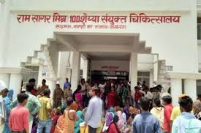
Figure 1- Ram Sagar Mishra 100 Bed Combined Hospital

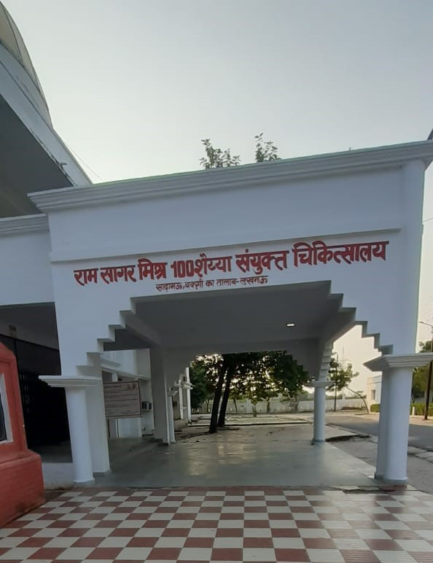
Figure 2- Ram Sagar Mishra 100 Bed Combined Hospital
The hospital has separate departments divided for every different problem. Hospital has proper navigation signs and indicating boards to make the departments easier to find to the patients. The hospital provides proper facilities of 24 hours ambulance service and a medical team available to take care of the patients both day and night.

SECTIONS IN RAM SAGAR MISHRA 100 BED COMBINED HOSPITAL
- Emergency Ward
- Ortho and child care ward
- Pathology
- Pharmacy
- Radiology
- OT (Operation Theatre)
- Male-Female ward

EMERGENCY WARD
- An emergency ward is a dedicated area in a hospital that is organized and administered to provide a high standard of emergency care to people who are in need of, acute or urgent care including hospital admission.
- Emergency departments (ED) are an integral part of hospitals and medical practices and provide the best medical or surgical care to patients arriving in need of immediate care.
- EDs serve as the first point of contact, and people of nearly every age are given particular medical care based on their injury or illness.
- Emergency departments are well equipped with all the modern and essential equipment and accessories to render timely acute, emergency, trauma care services.
- A typical ED consists of nurses, doctors, and physicians who address a wide range of medical issues such as fatal injuries.
- Emergency care 24 hours a day is provided.
- At least one experienced physician is always available in the ED to take the charges of emergency cases.
Figure 3- Emergency Ward

ORTHO AND CHILD CARE WARD
- Orthopaedics is a medical specialty that focuses on the diagnosis, correction, prevention, and treatment of patients with skeletal deformities - disorders of the bones, joints, muscles, ligaments, tendons, nerves and skin. These elements make up the musculoskeletal system.
- Orthopaedists use medical, physical and rehabilitative methods as well as surgery and are involved in all aspects of heath care pertaining to the musculoskeletal system.
- Orthopaedists treat an immense variety of diseases and conditions, including fractures and dislocations, torn ligaments, sprains and strains tendon injuries, pulled muscles and bursitis ruptured disks, etc.
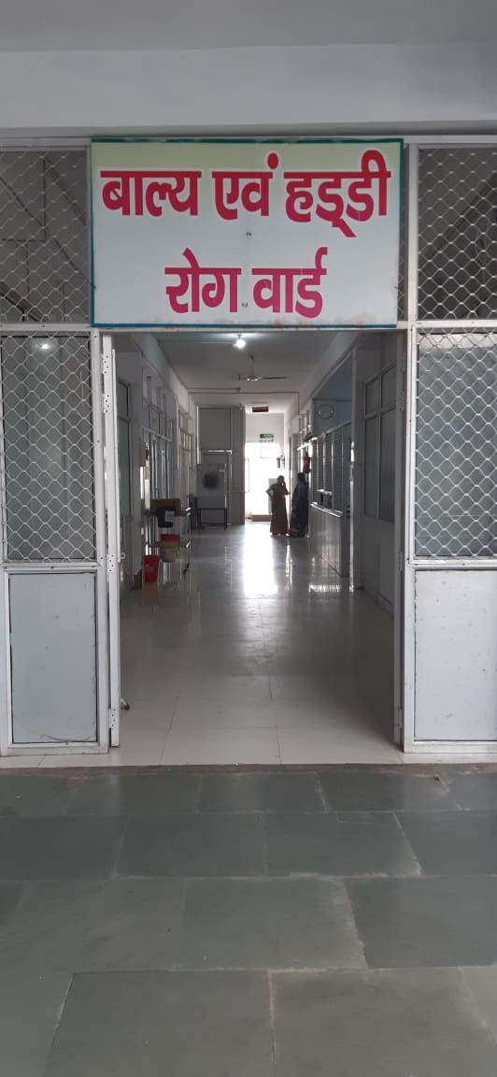
Figure 4- Ortho and Childcare Ward

Pediatric Ward
The pediatric ward staff are responsible for the daily management of conditions affecting children, from birth to 18 years of age.
- In child care ward, children and adolescents are treated who are suffering and are in need of specialised care.
- Specialized doctors and nurses are available for treatment of a varied range of diseases in children and for providing timely injections or doses.
- Most of the child patients who come for the treatment are suffering from JE (JAPANESE ENCEPHALITIS).

PATHOLOGY
- Pathology involves the examination of tissues, organs, bodily fluids, and autopsies in order to study and diagnose disease.
- Pathology also includes the related scientific study of disease processes whereby the causes, mechanisms and extent of disease are examined.
- Pathologists specialize in a wide range of diseases including cancer and the vast majority of cancer diagnoses are made by pathologists.
- In common medical practice, general pathology is mostly concerned with analyzing known clinical abnormalities that are markers or precursors for both infectious and non-infectious disease, and is conducted by experts in one of two major specialties, anatomical pathology and clinical pathology.
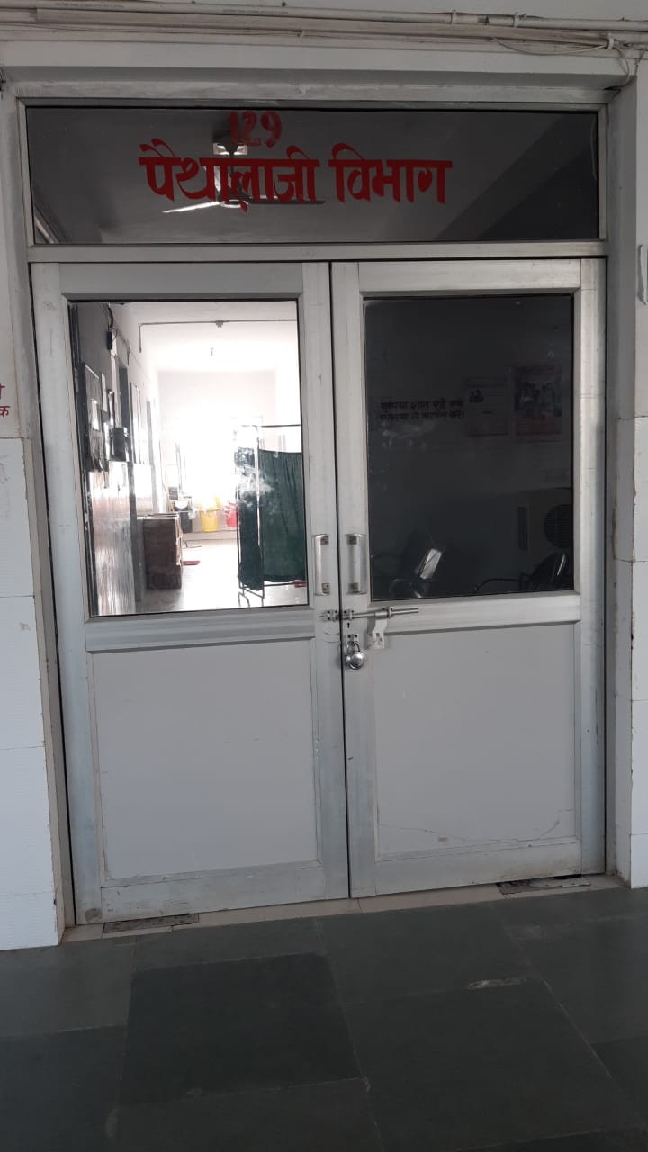
Figure 5- Pathology
PHARMACY
- Pharmacy is available in the hospital that have stock of a large range of medications.
- It typically provides medications for the hospitalized patients only and are not retail establishments.
- Some hospitals do have retail pharmacies with in them, which sell over the counter as well as prescription medications to the public, but these are not the actual hospital pharmacy.
- It also helps patients to understand their medications and how to take them.
- Pharmacists acquire expertise in the storage of data, distribution, and inventory control functions, and the management of data for drug histories, patient records, quality assurance programs, and drug information services.
The primary functions of Hospital Pharmacy are:
- Selection of reliable suppliers
- Storing and dispensing of Drugs
- Maintenance of manufacturing records
- Quality control of purchased and manufactured products
- Expecting and knowing the hospital demands

Objectives Of Hospital Pharmacy
1. To professionalize the functioning of the pharmaceutical services in hospital.
2. To ensure availability of the required medication at an affordable cost at the
required time.
3. To plan, organize and implement the policies of the pharmacy.
4. To perform functions of management of material, purchase, storage of essential medicines.
5. To maintain strict inventory of all items received and issued.
6. To counsel the patient, medical staff, nurses and others involved in patient care on the use of drugs, possible side effects, toxicity, adverse effects, drug
interactions etc.
7. To serve as a source of information on drug utilization.

Five Principles of Pharmacy
1. FIFO – First In First Out
2. LASA – Look Alike Sound Alike
3. LIFO – Less Life In First Out
4. VED – Vital Essential Desirable
5. GAAP – General Accounting Principles In Pharmacy

Care While Storing The Medicine
1. Narcotics drugs in safe custody (double lock).
2. Safe Refrigeration of medicines requiring certain temperature.
3. Have a ‘Master Chart’ at the entrance of medical store, showing the layout of racks, almirahs in store with list of medicines.
4. Display Emergency Drug List.
5. Display Essential Drug List.
6. Drug Formulatory of EDL on display (circulate to all departments).
7. Display expiry drug list mentioning date of expiry, batch number and quantity of the drug.
8. Do not keep drugs with direct contact of floor or direct sunlight near the window.
9. Keep inflammable drugs/ chemicals separate and away from other drugs.

Quality Tool For Improvement Of Process Of Purchasing And Maintaining Stock Of Drugs As PEREDL List

PDCA CYCLE

PLAN
- Training should be organized for staff to operate online system.
- Availability of budget to purchase drugs in case of shortage or delay.
- Staff as per requirement to avoid the overload.

DO
- Impart Training.
- Apply for budget to purchase medicine from local store.
- Manage timely order and transportation of drugs.

CHECK
- Availability of drugs.
- Time management of placing order and transportation of drugs.

ACT
- Periodic training.
- Maintaining adequate stock of drugs.

END RESULT: Drug shortage will be handled by this approach.

MALE-FEMALE WARD
A general ward is a large room, where people who need medical treatment and not suffering from any chronic disease stay.
FEMALE GENERAL WARD
This ward is dedicated to the care of female patients. Nurses are responsible for the daily management of acute and chronic medical conditions such as malaria, hypertension, diabetes mellitus, HIV, gastrointestinal conditions among others. Patients are admitted to the unit directly from the emergency department. The unit has accessories for oxygen therapy, suction and nebulizing of patients who may be in acute respiratory distress.

MALE GENERAL WARD
Admissions, monitoring and oxygen therapy are done at the male emergency ward. Staff manage conditions such as malaria, hypertension, diabetes, cerebrovascular accidents, renal failure among others. Nurse’s activities include participation in vital sign assessment and recording, medication administration, health education, wound dressings and ward rounds with physicians and physician assistants.

Figure 6 – Male-Female Ward

RADIOLOGY DEPARTMENT
It is a medical specialty that uses imaging to diagnose and treat diseases seen within the body. Radiologists use a variety of imaging techniques such as X-ray, ultrasound, computed tomography (CT), and magnetic resonance imaging (MRI) to diagnose and/or treat diseases.
- X-rays – used to look through tissue to examine bones, cavities and foreign objects. May be used with contrast agents to provide a live motion image, e.g., fluoroscopy to image the digestive system, or angiography to investigate blood vessels
- CT (computed tomography) – provides cross-sectional views (slices) of the body allowing disease to be identified and localised
- Ultrasound – uses high frequency sound. This technique is widely used in obstetrics, gynaecology and paediatrics and for patients with abdominal, vascular or musculoskeletal conditions
- MRI (magnetic resonance imaging) – provides high quality imaging of body parts without the need for radiation.
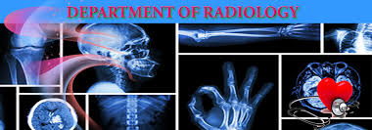

Figure 7 – Department of Radiology

OPERATIONS THEATRE
An operating theatre is where certain surgical procedures which means operations that involve cutting into and working inside a patient’s body take place. Complicated operations can last many hours.
The stages of an operating theatre;
Operations normally take place in four stages, which all require specialist staff:
1. pre-operative stage is when patients are informed about and prepared for the operation about to take place, by restricting their diet.
2. Anaesthetic stage is when the patient is either ‘put to sleep’ under general anaesthetic or has part of their body numbed under local anaesthetic.
3. Surgical stage is when the operation is performed in the operating theatre
4. Recovery stage is when the patient is transferred to a ward for further care and treatment.
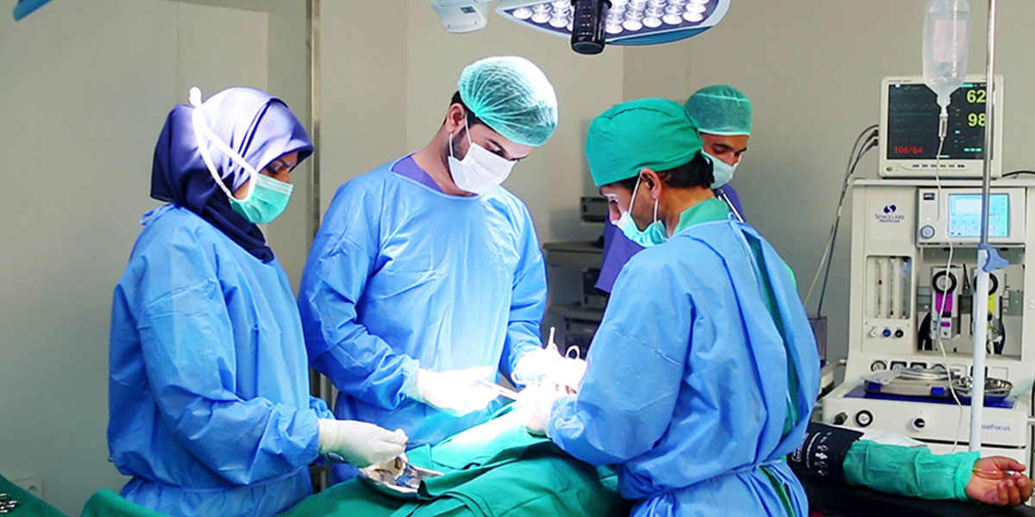

Figure 8 - Operations Theatre

HOSPITAL INTERNSHIP ACTIVITY
Hospital Internship Activities include –
1. First Aid Treatment
2. Injections
3. Dressing
4. Prescription
5. Dispensing Procedure
6. Diagnostic Report
7. Patient Observation Chart

FIRST AID TREATMENT
First Aid is immediate medical assistance to an ill or injured until the illness or injury is fully dealt with. It generally consists of a series of simple, potentially life-saving steps that an individual can be trained to perform with minimal equipment.
First aid procedure
- Laying the person flat.
- Opening their airway and assessing for breathing.
- Loosening any restrictive clothing around their neck or their waist.
- Consciousness is usually quickly regained with these first aid measures.
- If the person remains unconscious, check for breathing again and, provided that they are breathing, put them into the recovery position. Call an ambulance and refer for further assessment as needed.

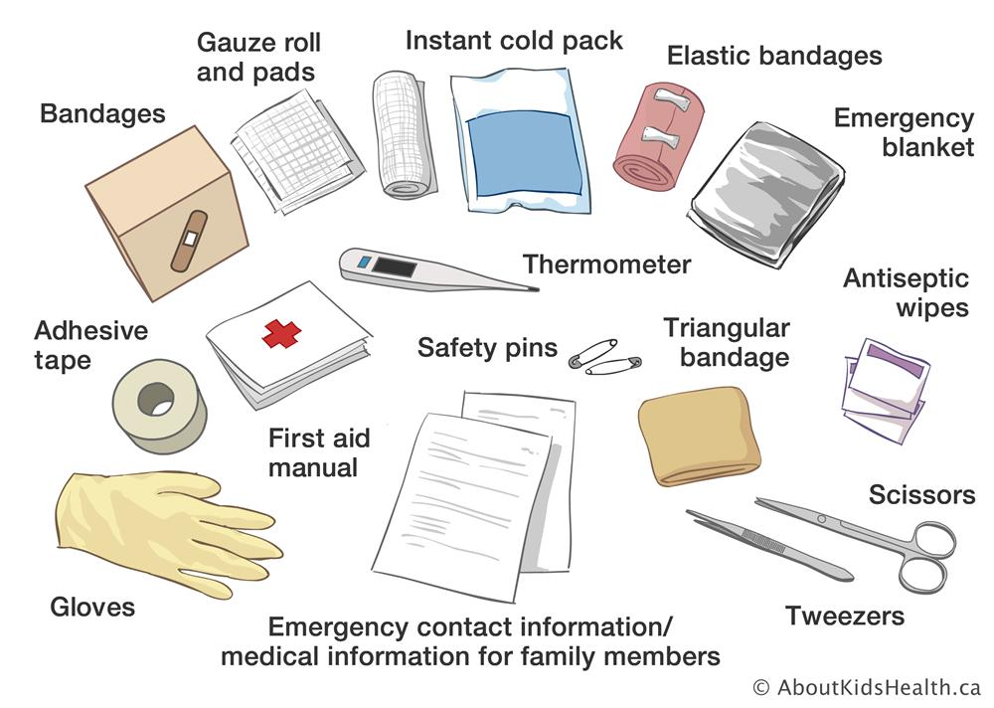

Figure 9 - First Aid Essentials
The person should be encouraged to use the principles of 'paying the PRICE' and 'avoiding HARM' for the first 48-72 hours after the injury.
- Protection: from further injury.
- Rest: for the first 48-72 hours after injury, activity should be avoided. The use of crutches can be considered for lower limb injuries.
- Ice: a specialized ice pack wrapped in a cloth can be applied for 15-20 minutes every 2-3 hours for the first 48-72 hours after injury.
- Compression: helps to reduce swelling. An elastic bandage can be applied around the affected limb. Remove at night. Ensure that the bandage is not too tight.
- Elevation: as far as possible, elevate the injured area above the level of the heart for the first 48-72 hours, ensuring that it is comfortably supported.

Avoid HARM for the first 72 hours after the injury:
- Heat: including heat packs, hot baths, saunas.
- Alcohol: this can increase swelling and bleeding.
- Running: or other forms of exercise.
- Massage: this can increase swelling and bleeding.

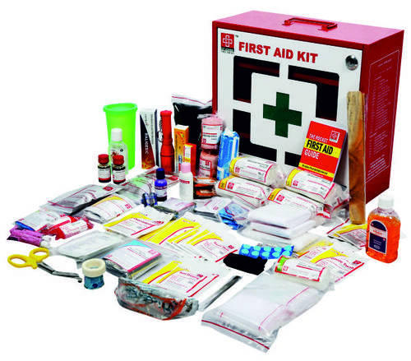
Figure 10 - First Aid Kit
METHODS OF INJECTIONS
An injection is a way of administering a liquid to a person using a needle and syringe.
The four most frequently used types of injection are:
- Intravenous (IV) injections. An IV injection is the fastest way to inject a medication and involves using a syringe to inject a medication directly into a vein.
- Intramuscular (IM) injections. IM injections are given deep into a muscle where the medication is then absorbed quickly by surrounding blood vessels.
- Subcutaneous (SC) injections. SC injections are injected into the innermost layer of the skin called the subcutis or hypodermis, which is made up of a network of fat and collagen cells. SC injections are also known as ‘subcut’ or ‘SQ’ injections. These injections work more slowly than an IV or IM injection because the area does not have such a rich blood supply.
- Intradermal (ID) injections. ID injections are given directly into the middle layer of the skin called the dermis. This type of injection is absorbed more slowly again than IV, IM or SC injections.
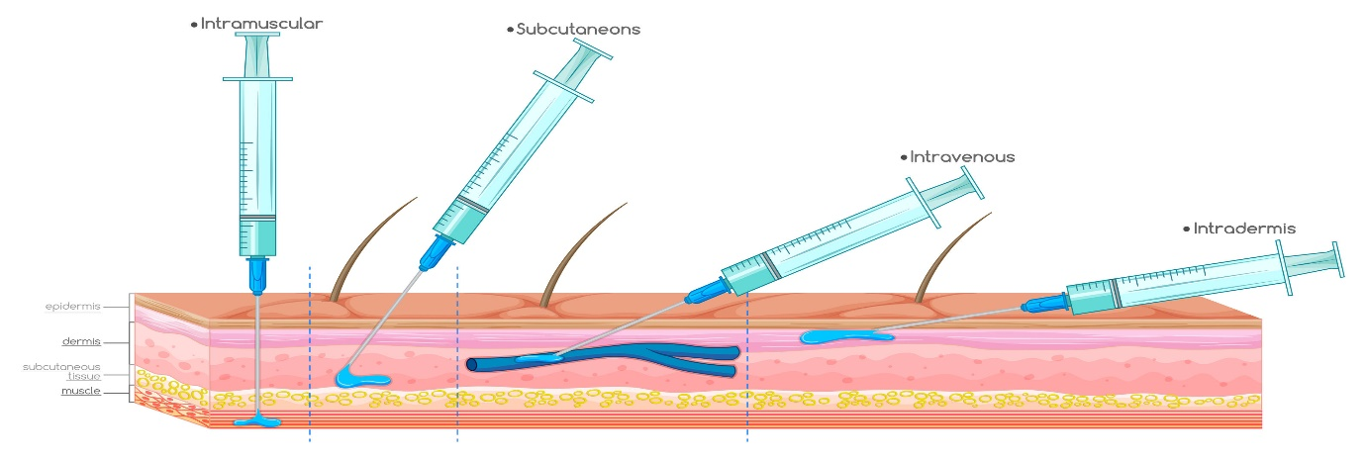
Figure 11 - Types of Injections
Technique of needle use
Proper needle use is important to perform injections safely, which includes the use of a new, sterile needle for each injection. Needles should not be shared between people, as this increases risk of transmitting blood-borne pathogens. In addition, it is not recommended to reuse a used needle to pierce a medication bag, bottle, or ampule designed to provide multiple doses of a medication, instead a new needle should be used each time the container must be pierced. Aseptic technique should always be practiced when administering injections. This includes the use of barriers including gloves, gowns, and masks for health care providers. It also requires the use of a new, sterile needle, syringe and other equipment for each injection, as well as proper training to avoid touching non-sterile surfaces with sterile items.
Disposal of used needles
Used needles should be disposed of in specifically designed sharp containers to reduce the risk of accidental needle sticks and exposure to other people. In addition, a new sharp container should be begun once it is 3⁄4 full. A sharps container which is 3⁄4 filled should be sealed properly to prevent re-opening or accidental opening during transportation.

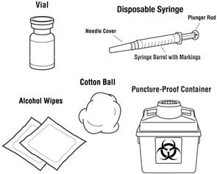
Figure 12 - Disposal of used needles

DRESSING
A dressing is used to protect a wound and prevent infection, but also to allow healing. A dressing should be large enough to totally cover the wound, with a safety margin of about 2.5 cm on all sides beyond the wound. A sterile dressing may be used to control bleeding from a major wound or to absorb any discharge from a minor wound.
A bandage is used in combination with a dressing where a wound is present. A roller bandage is used to secure a dressing in place. A triangular bandage is used as an arm sling or as a pad to control bleeding. It may also be used to support or immobilise an injury to a bone or joint or as improvised padding over a painful injury. A tubular gauze bandage is used to retain a dressing on a finger or toe.

The seven most commonly used wound dressings-
1. Hydrocolloid- Hydrocolloid dressings are impermeable to bacteria, which is what makes them so effective at preventing infections. They are also long-lasting, biodegradable, and easy to apply.
2. Hydrogel- It can be used for a range of wounds that are leaking little or no fluids. Hydrogel can also be used for second-degree burns and infected wounds.
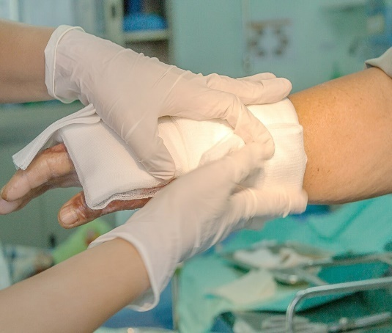
Figure 13 - Dressing
3. Alginate- These dressings absorb excess liquid and create a gel that helps to heal the wound or burn more quickly. These dressings require changing around every two days, sometimes more, due to the amount of liquid that they absorb and the nature of the wound. Changing them too often could cause too much dryness or could lead to bacteria penetrating the wound. These should only be used for wet wounds with high liquid drainage; else they can hinder healing by drying out wounds too quickly.
4. Collagen- Collagen dressings can be used for chronic wounds or stalled wounds, pressure sores, transplant sites, surgical wounds, ulcers, burns, or injuries with a large surface area. Collagen dressings encourage the wound healing process in a range of ways; these include by helping to remove dead tissue, aiding the growth of new blood vessels, and helping to bring the wound edges together, effectively speeding up healing.
5. Cloth dressings- These are the most commonly used dressings, often used to protect open wounds or areas of broken skin. They are suitable for minor injuries such as grazes, cuts or areas of delicate skin.These dressings come in all shapes and sizes, from small coverings for fingers to larger ones for wounds across wider areas of the body. As well as pre-cut dressings, these also come in a roll option that is made to be cut to size.
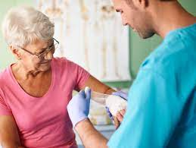
Figure 14 - Dressing Technique
PRESCRIPTION
Prescription is defined as a written or in any other form document issued by a Registered Medical Practitioner or any other licensed practitioners. Prescription is a way of communication between physician and pharmacist in which physician and other healthcare professionals authorized pharmacist to dispense or compound a specific prescription drug for a specific patient or caretaker. It is often abbreviated ℞ or Rx.
Under Drug and Cosmetic Act, 1945, A Prescription should have following particulars:
“For the purposes of clause (9) a prescription shall
(a) be in writing and be signed by the person giving it with his usual signature and be dated by him;
(b) specify the name and address of the person for whose treatment it is given, or the name and address of the owner of the animal if the drug is meant for veterinary use;
(c) indicate the total amount of the medicine to be supplied and the dose to be taken.”

Contents of the Prescription :
- Prescribers office information: Name, qualification, address & Regn. No.
- Patient information: Name & address, Age, Sex, Ref. No.
- Date
- Rx Symbol (Known as Superscription Part)
- Medication Prescribed (Known as Inscription Part)
- Dispensing directions to Pharmacist (Known as Subscription Part)
- Directions for patient to be placed on label
- Refill, Special labeling and /or other instructions
- Prescriber’s signature and license (or) Drug Enforcement Agency (DEA) number as required.
SOME PRESCRIPTION ABBREVIATIONS
a.c | Before meal
a.m | morning
Aq. | water
Aurist | ear-drops
b. | twice
b.i.d | twice a day
Caps | a capsule
Charts | Powder papers; divided powders
c.c. | With food; with meals
H | At the hours of
H.s. | At bedtime
n. | At night
Narist. | Nasal drops
o.m. | Every morning
q.i.d | Four times a day
Table 1 - Prescription abbrevations

DISPENSING PROCESS
The consistent, repeated use of good dispensing procedures is vital in ensuring that errors are detected and corrected at all stages of the dispensing process. The term dispensing process covers all activities involved, from receiving the prescription to issuing the prescribed medicine to the patient.
The development and use of written standard operating procedures (SOPs) for the dispensing process will improve consistency and quality of work and can be used for training and reference. The framework for such SOPs may be based on the six major areas of activity:
1. Receive and validate the prescription
2. Understand and interpret the prescription
3. Prepare and label items for issue
4. Make a final check
5. Record the action taken
6. Issue medicine to the patient with clear instructions
and advice

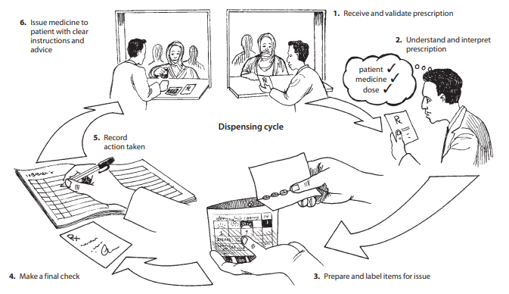
Figure 15 - Dispensing Process
PHYSIOLOGICAL PARAMETERS
1. pH of Blood:- 7.35-7.45
2. Hemoglobin
a. 13-18gm/dl in adult male
b. 12-16gm/dl in female
c. 9-15gm/dl in children
3. RBC Count (Red Blood Cell)
a. 4.5-5.5 microliter in male
b. 3.5-5.5 microliter in female
4. WBC Count (White Blood Cell) 4000-11000/cu mm
5. Platelet or Thromocytes count 1,50,000-4,00,000
6. Clotting time 2-6 min
7. Bleeding time 2-5 min
8. Blood Sugar Level 80-120mg/100ml
9. Blood cholesterol 150-250mg/100ml
10. Blood urea 8-26 mg/dl
11. Creatinine 1-2mg/dl
12. Sperm count 60-150 million per ml
13. Heart rate 70-80 beats/min
14. Blood pressure 80-120mm /Hg

WASTE MANAGEMENT IN HOSPITALS
In hospitals there are medical waste such as infectious items, chemicals, expired pharmaceuticals, radioactive items, and sharps (used needles, lancets etc.) are hazardous and, if not properly disposed or treated, can be lethal and a threat to the environment.
Color-Code Containers and Waste Bins
There are various types of medical wastes which are necessary to be disposed. Every waste from the hospital has separate identification and have different methods for their disposal. Segregating medical wastes based on their type helps ensure that each waste is discarded, transported, and destroyed properly. Waste bin color coding in hospitals help healthcare staff easily segregate waste and identify which waste goes to which container to help and prevent issues arising from random or improper disposal.
Healthcare waste segregation is done ideally at the very first opportunity to avoid hazardous hospital waste from getting mixed with regular waste.

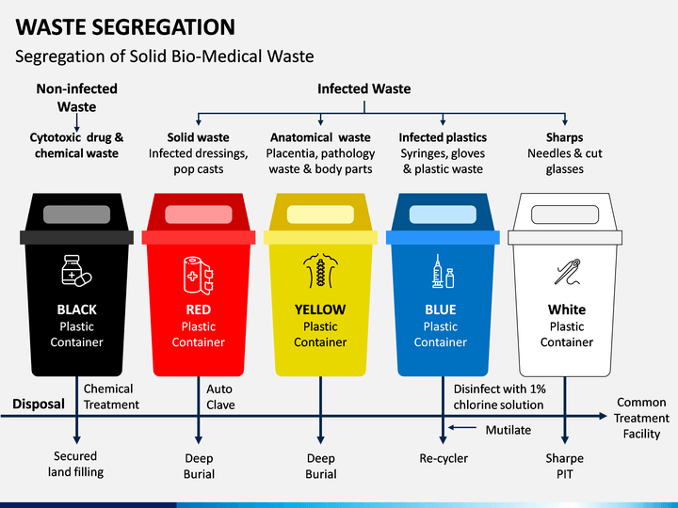
Figure 16 - Waste Segregation
These are easy to use and they help get more things done in shorter period of time.
Monitoring checklists also help ensure that people get their daily, weekly, and monthly task done on time.
These are just some of practices that can be done to ensure proper medical waste management in the healthcare facility:
- It minimizes the spread of infectious and reduces the risk of accidental injury to staff, patients, visitors, and the community.
- It reduces the likelihood of contamination of the soil or ground water with chemicals or micro-organisms.
- It attracts fewer insects and rodents and does not attract animals.
- It helps provide an aesthetically pleasing atmosphere.
OBSERVATION
Because of this, I came to the conclusion that the hospital is a place where people of all kinds go to bring their problems, which they trust the medical staff to handle. Work can be done in the hospital by maintaining a clean environment.
The medical staff members and Doctors all provide the patients a hostile and amusing treatment while paying attention to their problems.
Every department operates in a distinctive way, and at the end of the day, it completes the entire task.
Without any disrespect, patients receive their injections or pills and they get treatment right away. They can always rely on the nursing team to take care of their requirements. Hospitals ought to use this kind of approach.

RESULT AND DISCUSSION
45 Days hospital training has been completed as per the university curriculum and the work was performed in different section of the hospital like emergency, IPD, OPD, dispensary and store.
The hospital is the most interesting part of the university syllabus, it provides us a huge explore to learn and utilize all the knowledge.

CONCLUSION
The training in a hospital gives us a conclusion that the training in the hospital was really necessary as it now only helped us to see a hospital operates, but it also help me to learn basic function of it like first aid care how to give injection and dispensing of drugs etc.
The conclusion drawn out can be that I have finally learned as to how important role a hospital plays in people lives and that the hospital staff can go to save them since it’s their duty. Since Ram Sagar Combined Hospital receives only 1 rupee per patient, it also shows us their good deed towards mankind and to their service.
BIBLIOGRAPHY

Pharmacy Department- https://en.m.wikipedia.org/wiki/Pharmacy
Emergency Department- https://en.wikipedia.org/wiki/Emergency_department
OPD- https://byjus.com/full-form/opd-full-form
General Ward- https://en.wikipedia.org/wiki/General_Ward
Pathology Lab- https://www.healio.com
Dressing department- https://en.wikipedia.org/wiki/Dressing_(medical)
Diagnostic report- https://www.ibm.com/docs/en/tnpm
Dispensing- https://www.bccnm.ca/RN/learning/medication/Pages/dispensing.aspx
Injection- https://www.medicalnewstoday.com/articles/types-of-injections#side-effects
Prescription- https://www.pharmaguideline.com
Ortho and childcare ward- https://en.wikipedia.org/wiki/Child_care
Pediatricward- https://www.sciencedirect.com/topics/nursing-and-health-
Male female ward- https://www.mmh.mw/male-and-female-ward-and-surgical-services/
Radiology department- https://www.sciencedirect.com/topics/nursing-and-health-
Operation theatre- https://en.wikipedia.org/wiki/Operating_theater

